Safe Guarding Team
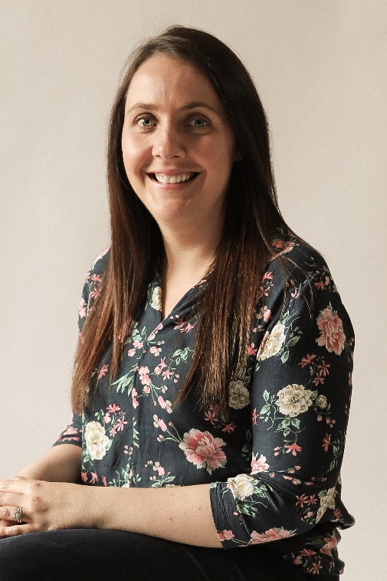
Mr White Mrs Mc Court
Principal Designated Teacher
Mrs Hurson Mrs Mc Parland
Deputy Designated Teacher Deputy Designated Teacher

