St Michael’s PS Clady

Prospectus
2022-23

St Michael’s PS Clady

GENERAL INFORMATION

School St Michael’s Primary
Address 62 Cladymore Road
Mowhan
Armagh
BT60 2EP
Telephone (028) 3750 7363
Website www.stmichaelspsclady. Net

Chairman of the
Board of Governors Mr Joe McGleenan
Principal Mr John White
Teachers 2019/2020
P1 - P2 Mrs NIAMH Mc Court
P3-P4 Mrs C Hurson/ Mrs G Mc Parland
P5 Mr John White
P6-P7 Mrs M Mc Leod
Enrolment September 2022 73 children

St Michael’s is a Catholic Maintained Primary School for both boys and girls and is under the control of the Catholic Council for Maintained Schools (CCMS)

Board of Governors 2022
St Michael’s PS Clady

Trustee Representatives
- Fr Greg Carville
- Denise Crozier (Trustee)
- Mr Adrian Cassidy (Parent Trustee)
- Mrs Cathy Mc Laughlin

SELB Representatives
- Joe McGleenan

- Mary McGuigan

DENI Representatives
- Mrs Geraldine Mc Mahon

Parent Representative
1 Brendan Fearon
Teacher Representative
- Mrs Mary Mc Leod

Principals (Non voting)
Mr White

St. Michael’s Mission Statement

As a Catholic school, St Michael’s Primary School aims to provide all its pupils with the best education possible in a happy and caring environment where every child can feel secure, valued and respected as an individual.

We will maintain a clean, attractive and welcoming school. Children will be encouraged to maintain an organised school, developing a respect for their own and others property. Children are encouraged to form their own opinions, make decisions, get involved and understand the impact their own and others’ actions have on the environment.

We seek high standards of educational achievement from our children and high standards of professionalism from our teachers. The children should be interested in their activities and be well motivated due to effective teacher planning and delivery. We aim to foster behaviour which enables children to have respect for themselves and others and to act responsibility with an awareness of boundaries.

We will try to promote a strong community spirit with parents recognising that they have important contributions to make in their child’s education. They should feel supported in their concerns and recognise the school as a place which is open and receptive of their needs.

In St Michael’s Primary School the Catholic ethos permeates all aspects of school life. It reflects the values, attitudes, beliefs and practices of our Catholic faith and it involves all members of the school community: pupils, parents, teacher, ancillary and auxiliary staff, and governors. All members of the school community have an important role to play in the smooth running and success of our school.

In St Michael’s Primary School each member of the school community is valued and has an important contribution to make to the life and work of the school. We are committed to providing a range of learning experiences for all our pupils which will enable them to explore and develop their talents and abilities.

Developing independence is an integral part of each child’s education throughout the school. It is encouraged by creating the atmosphere and opportunities across the curriculum so that children can question, explore, investigate and learn from their own endeavours.

Our school vision was summed up by a parent who always told his children:

“Work hard, be happy”

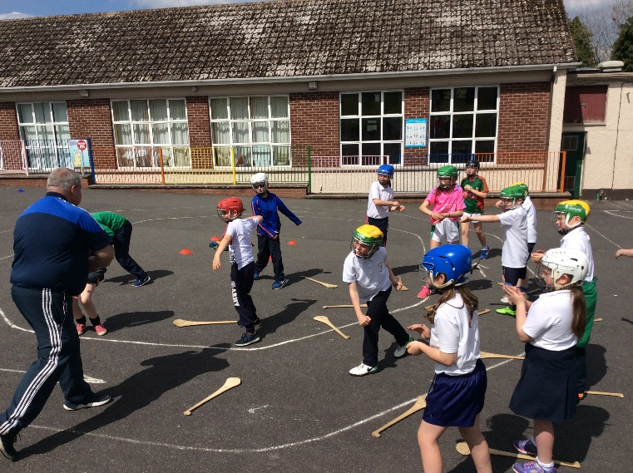
GAA football and camogie
Basketball
On the
MUGA

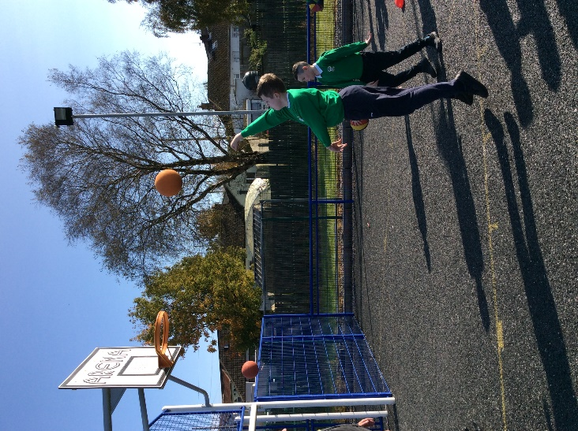

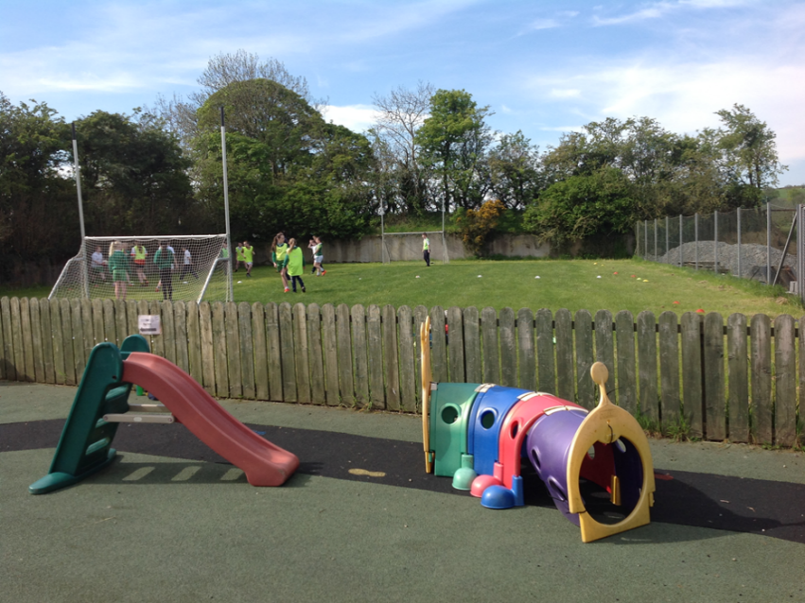
Excellent
play
facilities

Our Aims and Purposes

1. Share and promote our Catholic ideals, values, and beliefs so our whole community has mutual respect.

2. Promote the spiritual, personal, social health and academic goals desirable for all our pupils in order to mold them into caring and responsible citizens of the future.

3. Enable our children to become articulate, literate and numerate with early intervention in place as required.

4. Ensure all may become independent and confident learners in an inclusive, diverse and well-resourced environment.

5. Encourage the children to develop lively, enquiring, imaginative and creative minds with the ability to question and argue rationally.

6. Highlight the dignity and worth of each individual and promote the development of the whole person to the best each can be as valuable contributors to running our school effectively.

7. Promote the multicultural nature of society and to foster respect for those with different religions, beliefs and ways of life.

8. Involve parents, local schools and the local community as active participants and mutual partners in the education of our children.

9. Ensure we deliver the Northern Ireland Curriculum to the highest standard and include a broad range of rich and meaningful experiences as part of their development in school time or as extracurricular activities.

10. Foster children's awareness of and a caring attitude towards their local and wider community and environment, and of the effects their actions can have on them.

ORGANISATION OF THE NORTHERN IRELAND CURRICULUM
Learning, Teaching and Assessment are the focus of our work in school. We strive to ensure each child will achieve his / her potential. We offer a broad and balanced curriculum following the requirements of the N.I Curriculum.
The areas of learning include:
Language and Literacy Mathematics and Numeracy Personal Development & Mutual Understanding The Arts – Music, Art & Design and Drama Physical Education The World Around Us
Thinking skills and Personal Capabilities and Cross Curricular Skills – Communication, Using Mathematics and Using ICT are infused throughout the curriculum.
Pupils in the Foundation Years learn through a programme of play based learning and Key Stage One pupils learn on a cross-curricular basis through Activity Based Learning.
Religious Education plays a major role in our school. We use „the Alive O Programme‟ which gives the child a foundation in the Catholic faith and helps to prepare them for sacraments. We are currently updating to the new religion programme, Grow In Love.
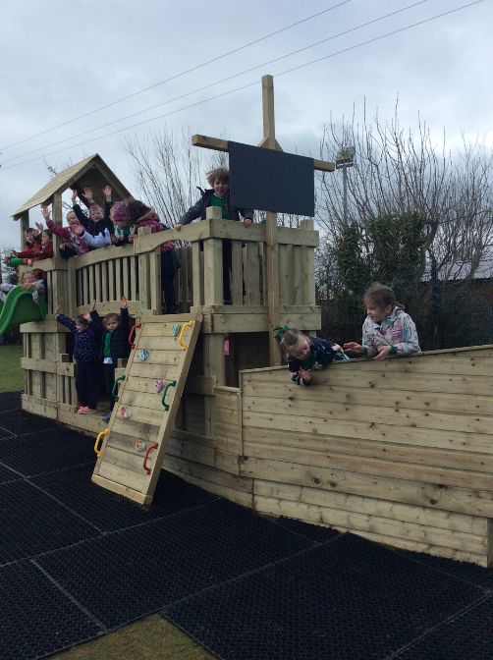

Fun on the climbing frame

RELIGIOUS EDUCATION
What is distinctive about Catholic Education is that faith in Jesus Christ is the centre point of all the child’s personal and intellectual development. There is no separation between Faith and Life. Catholic Education for us is primarily formation in Faith. The Faith, which is handed on by being lived in the family, the community and the school, is also reflected upon and deepened through following the religious education programme. In the Catholic School, Religious Education is, therefore, much more than a subject but rather pervades the whole life of our school holding a central position in the curriculum and is accomplished in two equally important and complementary ways:
• through the totality of experiences in the school
• through the Religious Education Programme, Grow in Love, which incorporates fully the Proposed Core Syllabus for Religious Education in Grant Aided Schools in Northern Ireland..
MASSES & ASSEMBLIES
Devotion to Our Lady, St Michael, St Patrick, St Bridget, The Sacred Heart, The Saints and Church Celebrations are fostered through meaningful assemblies and the setting up of altars and shrines.
Each school year begins and ends with a School Mass to which you are invited to attend.
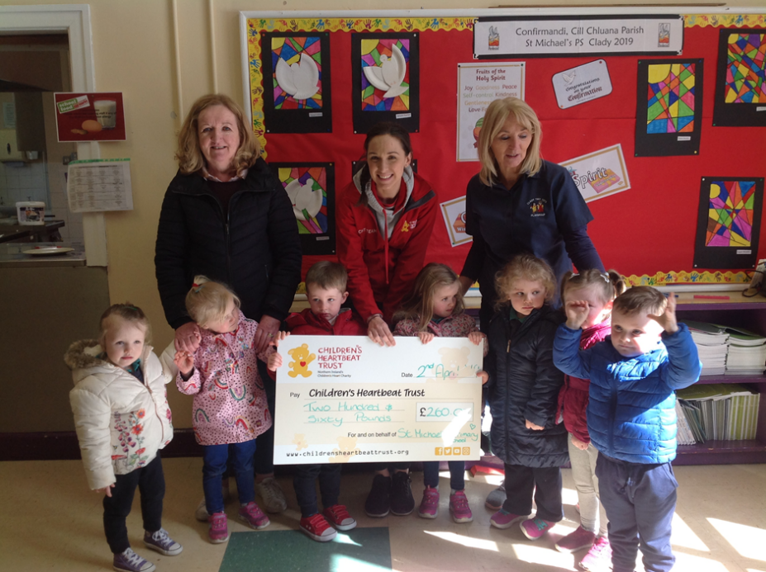
Charity fundraising with Clady Tiny Tots

EXTRA CURRICULAR ACTIVITIES
The school offers a wide variety of activities usually run outside normal school hours under the guidance of members of staff. These include Gaelic football, camogie, swimming, ICT, dance, choir practice, art and cycle proficiency.
The children are expected to show commitment to the school by participating as required in team sports, choir practice, school outings and school productions.
Educational visits to places of local interest figure prominently in the school Curriculum
Pupils will have the opportunity to become involved in the following activities
• Primary School’s GAA Football Leagues
• Camogie Tournaments
• A range of indoor sports
• Quiz Competitions

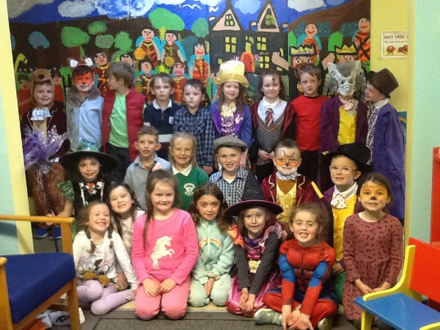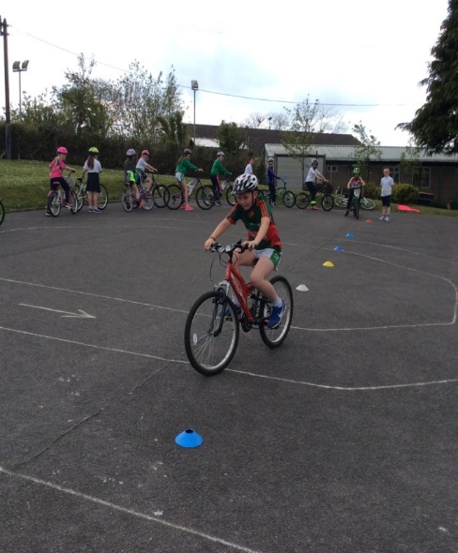

World Book Day Cycling Proficiency

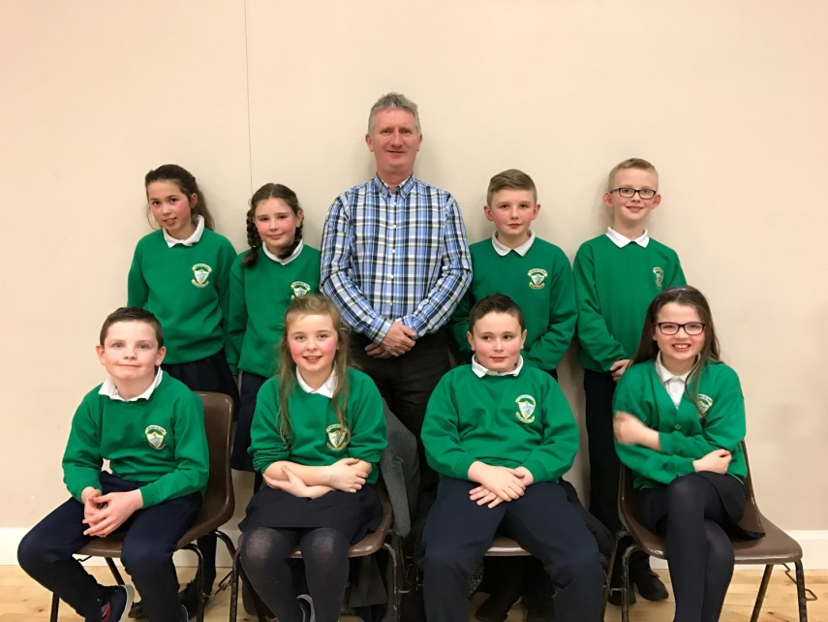
Credit Union Quiz
ICT
In the
classroom
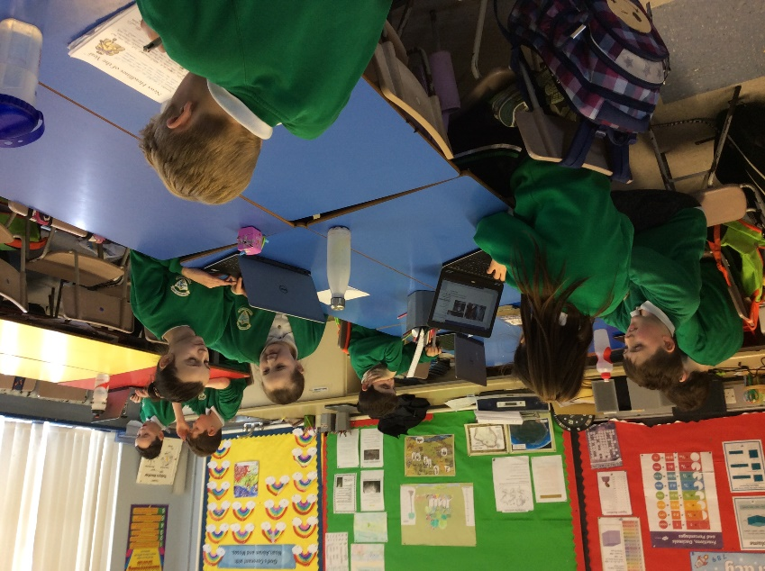
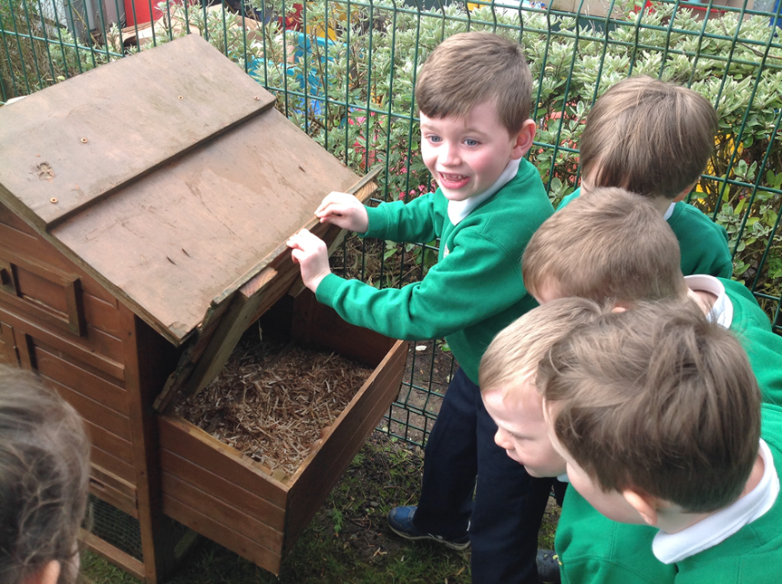
Looking after hens in school
ASSESSMENT FOR LEARNING
Assessment for Learning strategies are implemented in each class. The learning potential is shared with the pupils who are encouraged to take responsibility for their own learning appropriate to the age group. Pupils are involved in setting targets for their own learning and self-evaluating at the end of a lesson. Pupils are also involved in self and peer assessment.
Marking for improvement aims to help pupils improve the standards of their work
ASSESSMENT OF LEARNING
Formative assessment is on-going throughout the year. Teachers meet with parents in term one to review pupils’ progress and plan for the next steps in learning. Summative assessment and reporting to parents is carried out annually in the Summer Term.
Assessment in Primary One and Two is on-going and informal. In Primary Three to Seven children will be tested through class check-ups in core subject areas. Assessments in other curricular areas will be based on class work and teacher observations. Additionally, a pupil file is kept on each child containing samples of work completed each year, which serves as a record of achievement and progress.
A report for each child is sent home to parents at the end of the school year.
In addition the children will complete a number of standardised tests that will allow the teacher to determine how they are progressing in English and Maths.
Standardised Assessments
Mathematics – Progress Test in Maths (PTM) P3-P7
English – Progress Test in English. (PTE) P3-P7
CAT 4 Intelligence Test P3 and P5
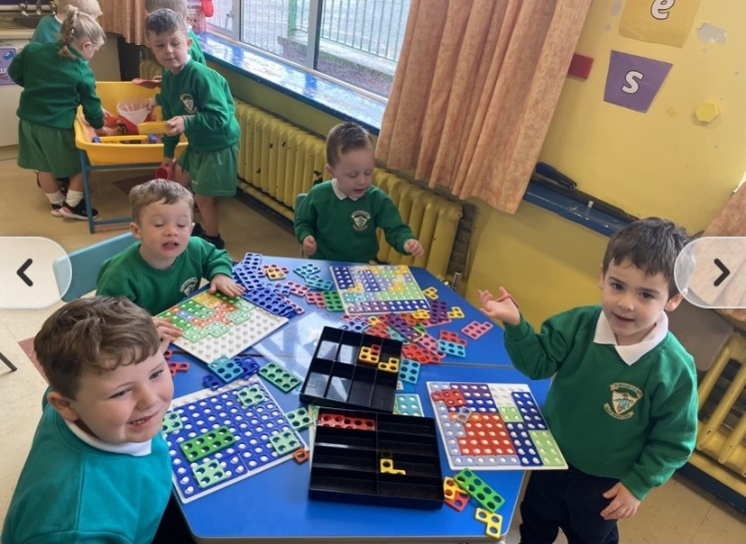
CHILDREN WITH SPECIAL EDUCATIONAL NEEDS
Some of the children attending the school will have special educational needs. These may arise from the child’s physical incapacities or his/her learning abilities. As it is the intention of the school to maximise the potential of each of its pupils the school will endeavour, with its resources, to meet these needs.
Each class teacher will have initial responsibility for providing remedial help within the child’s own class. If this does not prove sufficient for the child the school will involve and work closely with EA in determining a child’s Special Educational Need in accordance with the Code of Practice. This involves close co-operation between teachers, school medical authorities, educational psychologists and parents.
The EA Special Education Needs Team will make the final decision about the appropriate form of education.
St Michael’s Primary School has the necessary equipment and resources, both material and personnel, to facilitate wheelchairs.
The Special Educational Needs Policy is available on request from the School Principal.

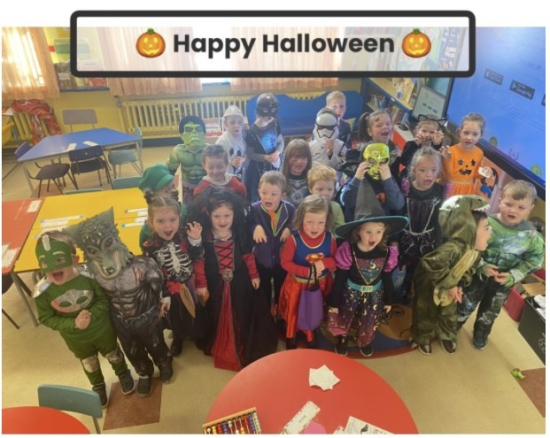
Primary 1-2 Halloween Fancy Dress
COMPLAINTS REGARDING THE CURRICULUM
Where parents consider that the curriculum provision for their child is not satisfactory they are invited to express their concern to the school through:
1. The class teacher
2. The Principal
3. The school Board of Governors
4. The CCMS complaints tribunal for curriculum matters

In making a complaint, all parties involved are asked to follow the procedures as outlined in the school’s Complaints Policy. A copy of the school’s Complaints Policy is available on request from the school Principal.
If a parent has an issue relating to their child, the class group or a wider school issue in general the following steps should be taken:-
If you have an initial query please contact the class teacher who will establish the facts and provide information or explanation. An enquiry will be conducted with the appropriate staff members and the class teacher who will in turn be responsible for any liaisons between the parties.
If the outcome is not satisfactory the complaint may be taken to the School Principal. In the event of grievance against the class teacher the complaint is taken straight to the School Principal. All matters will be discussed confidentially. It is important that any problem is dealt with quickly and effectively, so that, hopefully, they do not escalate into a larger issue.
If you still believe that your concern/complaint has not been dealt with in a satisfactory manner, or in a case where you decide to raise an issue at a higher level, you may write to the Chairperson of the Board of Governors. The Chairperson will be responsible for bringing your concern/complaint to a Governors’ sub-committee, which will investigate.

The school ‘s complaints procedures are available on the web site or from the office.

Homework
Homework is anything that children do outside the normal school hours that contributes to their learning in response to guidance from the school. We recognise that the time and resources available limit the educational experience that any school by itself can provide; children benefit greatly therefore from the mutual support of parents and teachers in encouraging them to learn both at home and at school.
Our policy is to set a sensible amount of homework to reflect and support these principles. It covers all years from P1-P7 and the frequency and amount of work given will obviously increase as the children progress through the school. It should however be noted that these are general guidelines and there may be variations at different times of the year as teachers match homework to the needs of their class and individuals.
With Covid 19, will reduce the amount of materials transferring between home and school, we will use e-learning wherever possible, For Foundation Stage (P1-P2), we will use SeeSaw, P3-P7 will employ Google Classroom and tools such as IXL, Accelerated Reader and BBC Bitesize,
SCHOOL DAY
In line with regulations as defined by the Department of Education and CCMS the Board of Governors have agreed the following structure for the school day, to ensure each child receives their entitlement to the Curriculum.
Primary 1- 2 9.15am to 2.00pm
Supervision is available from2-3pm each day at a cost of £1 per day
Primary 3-4 9.15am to 3.00pm
Primary 5 – 7 9.00am – 2:45pm
Pupils must not be left at the school until 8:45am daily
ABSENCES

If your child is absent from school, a note from the parent must be brought in on the day the child returns to explain the absence.
It is our legal obligation to inform the Educational Welfare Officer in the Education Authority when a child has missed 15% (or more) of school days in any given period. It is in the best interests of your child that all medical and dental appointments are made after school hours.
BOOST BETTER BREAKS
The school operates the Boost Better Breaks Scheme where all children eat a healthy snack at break time ie fruit/milk/water
Break 10.45am – 11.00am
Our school is a health promoting school and we are aware that habits formed in the early years stay with us. We actively promote healthy lifestyle messages through our teaching in all classes as well as through our health promotion week when we invite a wide range of health professionals into our school to talk to our children. As part of our health promotion the school has adopted the Boost Better Breaks Policy.
Therefore morning break consists of milk, water and/or fruit only.

DINNER/LUNCH
Children have the choice of a cooked dinner or packed lunch.
The cost of a dinner is £2.55 (Subject to change). Dinner money will be collected by class teacher and in order to manage this effectively we ask that the correct amount of money is brought in, in an envelope by the oldest child in each family, clearly marked with names and amount. Thank you for your co-operation in this matter.
MEDICATION
Medication will not be administered in school by a teacher. If your child has any illness problems or allergies, please inform his/her class teacher when he/she starts school and a medical plan will be put in place. Inhalers used by asthmatic children, will be made readily accessible during the school day.
HEADLICE
In the event of head lice parents should contact the school immediately. The school will then send out an information leaflet to all parents.
TOILETING ACCIDENTS
If a child has an accident the school will inform the parent and ask them to bring clean clothing to the school and change the child. A P1-P2 child who has an accident but we cannot contact a parent will be helped changed by two adults. A child will be encouraged to change themselves where appropriate. A change of clothes will be kept in school for this purpose. Parents are asked to wash and return the clothes as soon as possible thereafter. Parents will be informed of such accidents.

SCHOOL COUNCIL
Each year in September, following council elections, two pupil representatives are chosen from P5. The school council members receive appropriate training and experiences in order to fulfil their role as a councillor. They meet with the link teacher for half term meetings. The School Council is promoted as a forum for discussion for all pupils. Councillors learn to solve problems fairly, become more confident and learn to discuss issues that affect them. They also have an opportunity to become better listeners, improve the school environment and become involved with charity work.
Sickness
It is important that children are fit and well enough to enjoy and participate fully in school activities. Please do not send sick children to school. If a child is showing any symptoms of Covid 19 then you should contact your family doctor or PHA. Pupils should not attend school unless there is a negative result. This applies to a child who has a heavy cold, a high temperature, tummy upset, diarrhoea as well as other more serious contagious diseases:
Table of Incubation and exclusive periods for infectious illnesses
Illness Incubation period Period of Exclusion
Measles 10-15 days 7 days after rash
Chickenpox 10-14 days 14 days after rash appears
German Measles 14-21 days Not until advised by doctor
Mumps 18-21 days Not until advised by doctor
Whooping cough 7-10 days Not until advised by doctor
Impetigo 1-10 days Until Lesions are crusted and healed
Slapped Cheek 10-15 days Not until advised by doctor
Vomiting 48 hours after last incident
Diarrhoea 48 hours after last incident
Scarlet Fever 3-8 days Child can return 24hrs after
commencing appropriate antibiotic

Further information is on display on the parents’ notice board in the school and on www.publichealth.hscni.net

Please let us know if your child has any form of infection / contagious illness (including head lice) so that we can inform other parents. Following these guidelines will help us to protect your child's health and wellbeing. Please forward a note to school after your child’s return, explaining the reason for absence.

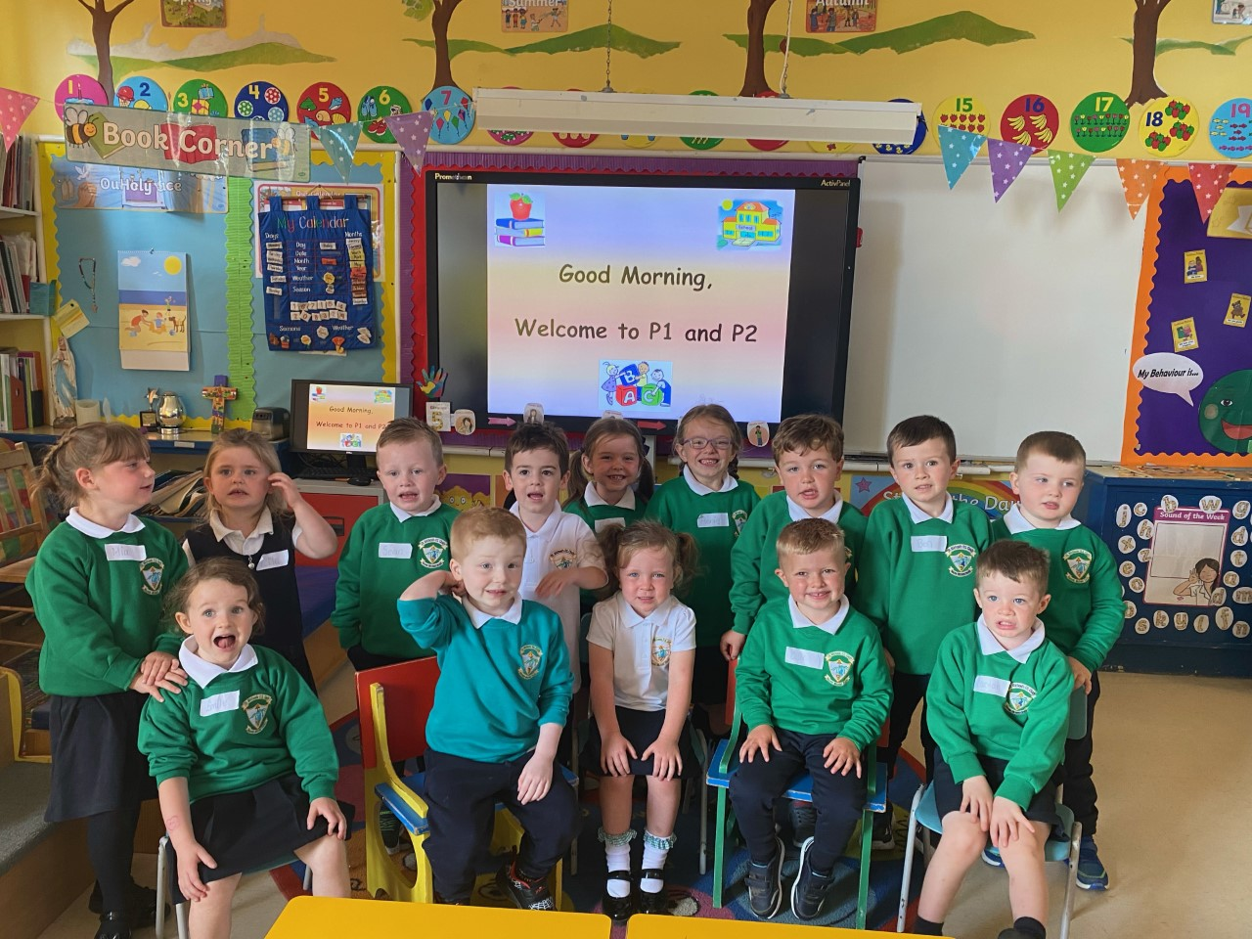

Primary 1 September 2022
PASTORAL CARE ARRANGEMENTS

The school recognises its responsibility to do everything to care for each pupil’s physical and emotional wellbeing and with this in mind will endeavour to provide a comfortable and safe environment for learning.

Each teacher has responsibility for the pastoral care of the children in his/her class and will welcome any information regarding difficult home circumstances, which may be causing a pupil distress or anxiety. Any such information will be treated with complete confidentiality.

A ‘Pupil Data Sheet’ is on file for each child. Parents are asked to indicate any medical problems the school should know about e.g. asthma sufferer, speech, sight, hearing problems, dietary problems and so on.

When a child is sick or injured in the school, the parent/guardian is first contacted and if necessary, requested to collect the child from school. Where a parent/guardian is not available, or is unable to get to the school, the child will be brought home or to a surgery if required.

In all cases it will be the school policy to act in the best interest of the child.
Written permission will be sought on admission regarding all off site visits and events that your child may attend throughout their time at the school.
If a parent wishes to collect his/her child at any time, other than normal home time, they must first seek permission from the Principal. The school will retain written notification of these requests.

The atmosphere of the school is based on good relationships between staff/pupils/parents. As a staff we work as a team, respecting each other’s roles and recognising individual talents and expertise. We are concerned with the needs and wellbeing of each child and the approaches and programmes we implement assist his/her personal development.

We recognise and value the important role parents play in their child’s education. Every effort is made to ensure that parents feel welcome.
The Child Protection Policy is available on request from the Principal.
Parents will receive a copy of the school’s Pastoral Care and Child Protection Procedures every two years.

Mrs Mc Court is the Designated Teacher for Child Protection and Mrs Hurson with Mrs Mc Parland are the Deputy Designated Teachers for Child Protection. Mr White, as principal, makes up the Safe Guarding Team.

This school takes seriously its responsibility to protect and safeguard the welfare of the children and young people entrusted to its care.
As part of the ethos of the school, the staff and governors are committed to:
• Encouraging and supporting parents/carers/guardians and working together in partnership with them.
• Listening to, relating effectively with and valuing each individual child or young person in our care.
• Ensuring that all members of staff, both teaching and support, full-time and part-time are properly trained and supported.

POSITIVE BEHAVIOUR POLICY

Discipline is the responsibility of every teacher in the school. Each teacher is responsible for the discipline of his/her class and also bears a share of responsibility for discipline throughout the school. The attitudes of staff are of great importance. It is they who, in the end, determine the environment in which good staff/pupils relations can develop. They are expected to set the right example to pupils in matters of dress, punctuality and commitment. They should consider themselves responsible at all times for the behaviour of pupils in their care.

All policy documents relating to pastoral care can be found on the school website.

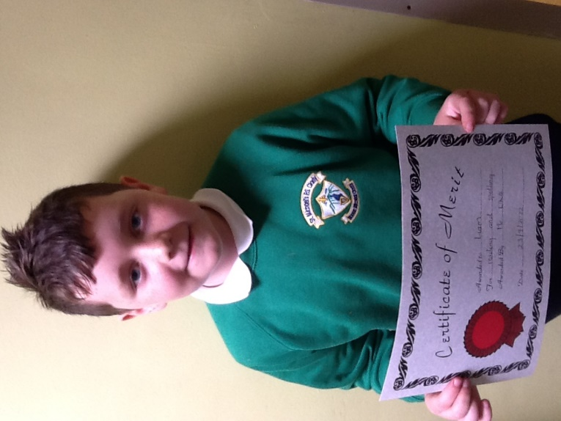

Student of The Week Award

RESPECTING OURSELVES AND OTHERS

Definition of Bullying

We recognise that bullying can occur and is very distressing for the victim. A Bullying Policy operates within the school. All staff are vigilant at all times to the possibility of bullying occurring and will, if any bullying behaviour is identified, take immediate steps to stop it happening, to protect and reassure the victim and to discipline the bully. Parents of both victim and bully will be contacted. An anti-bullying week focuses on anti-bullying strategies within the school and highlights important aspects of keeping oneself safe.

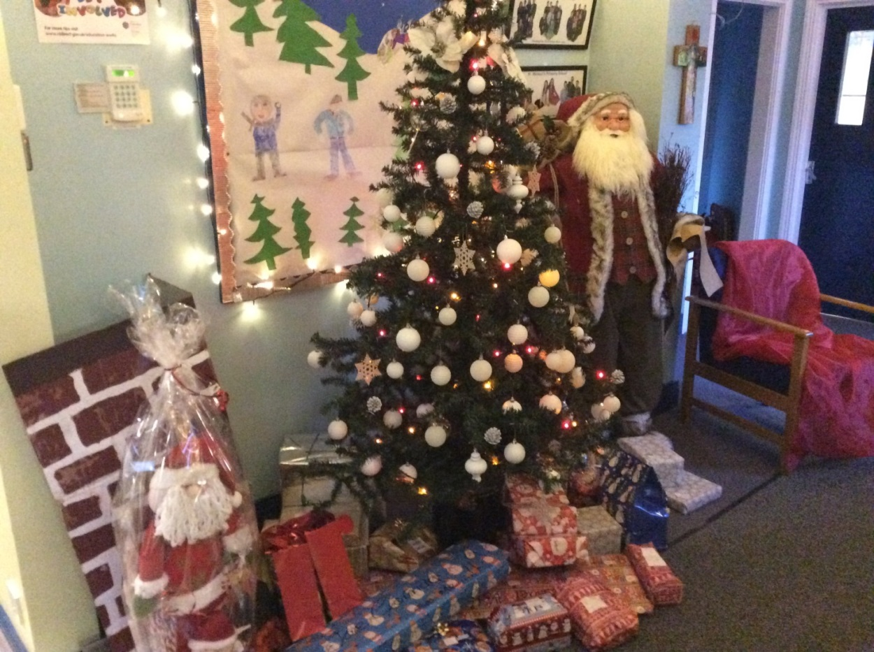

School entrance area at Christmas

PARENTAL INVOLVEMENT

St. Michael’s values its relationships with parents and enjoys strong links with the parish and the local community.

Before the child commences school, parents are invited to an induction meeting at which all the relevant information is disseminated, verbally and in a booklet.
Parents of all children receive a report of their child’s progress in June and are invited to a meeting with the child’s teacher on a one to one basis to discuss his/her progress.

Parents will be invited to the school for open evenings, Christmas concerts performances or such activities as occur from time to time.

Parenting programmes of different types will be arranged to inform parents of their child’s learning in areas of the curriculum and to support parents in helping their child at home.

Partnership with Parents

The school works in partnership with parents to meet the child’s needs. This means;
• We listen to the views of parents
• Parents are equal partners in decisions about their child’s education.
• Parents are kept informed about their child’s needs and progress.

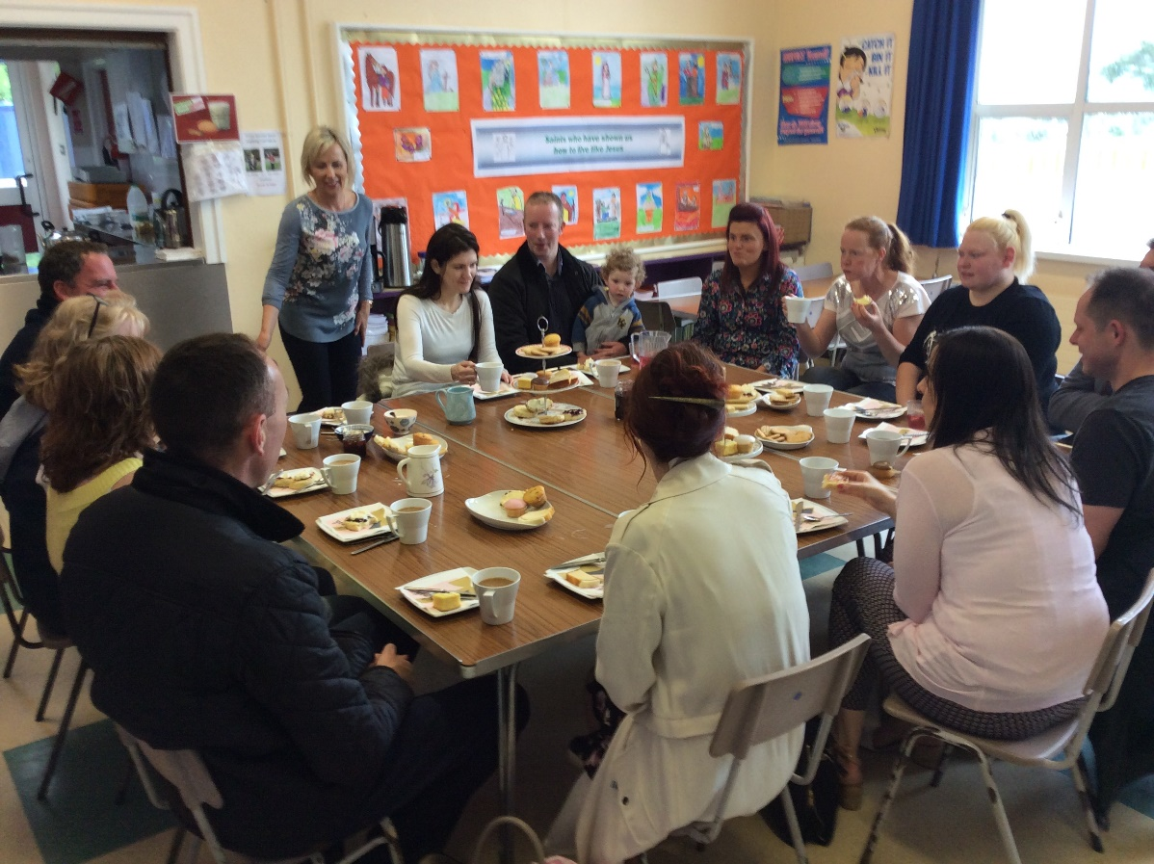

Friends’ Of St Michael’s prepare the tea for Induction Day

EDUCATIONAL VISITS

The school values highly the contribution Educational visits make to the all-round development of its pupils. Every opportunity to participate in such ‘visits’ is availed of beginning with visits to places of local interest and broadening out to places of interest in the wider community.

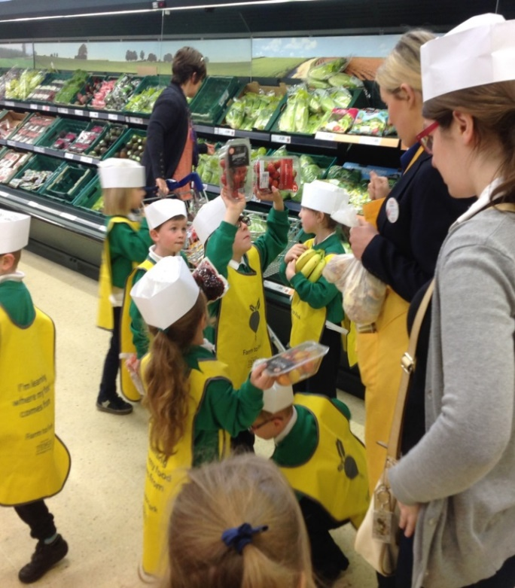
Educational visit to Tesco, Newry, as part of a project on food.

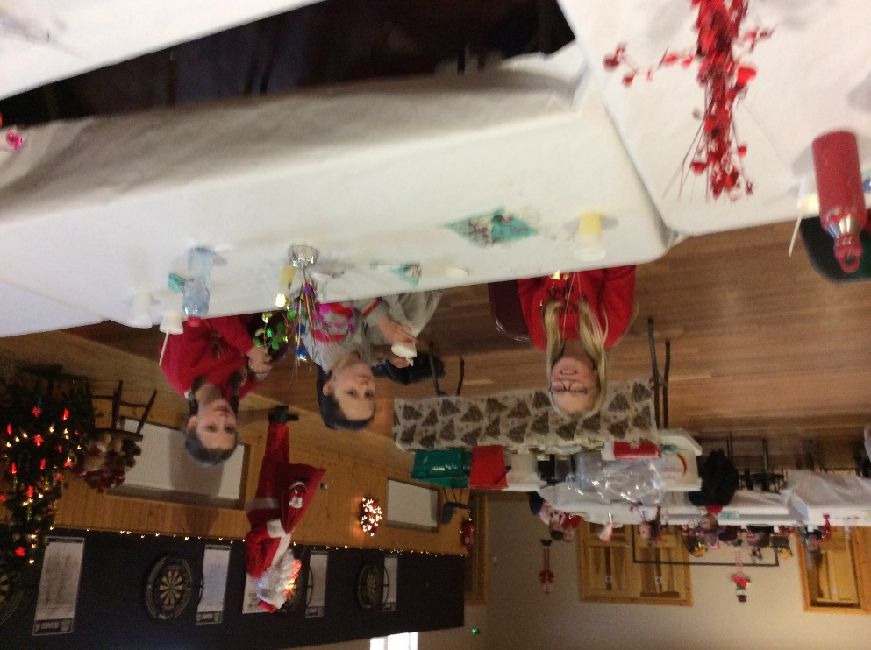
Christmas Dinner
December 2020

LINKS WITH OTHER AGENCIES

We see the school as a vital part of the Parish and take every opportunity to contribute to the life of the parish. In order to do this we liaise closely with our local priests. Fr Gregg visits our school regularly and so gets to know staff and the children.

We co-operate with, and fully support, the work carried out by the local Health Authority personnel and when necessary, we seek the help and advice of their statutory agencies. Visitors, like the school nurse, doctor and educational psychologist call at the school in order to cater for the needs of your child.

We work closely with local school. We team up with Granemore and Foley for religious events such as confirmation. We have an excellent relationship with St Patrick’s HS, Keady.

Sean South GAC are very supportive of the school and make their Hall available for PE, assemblies and special events.

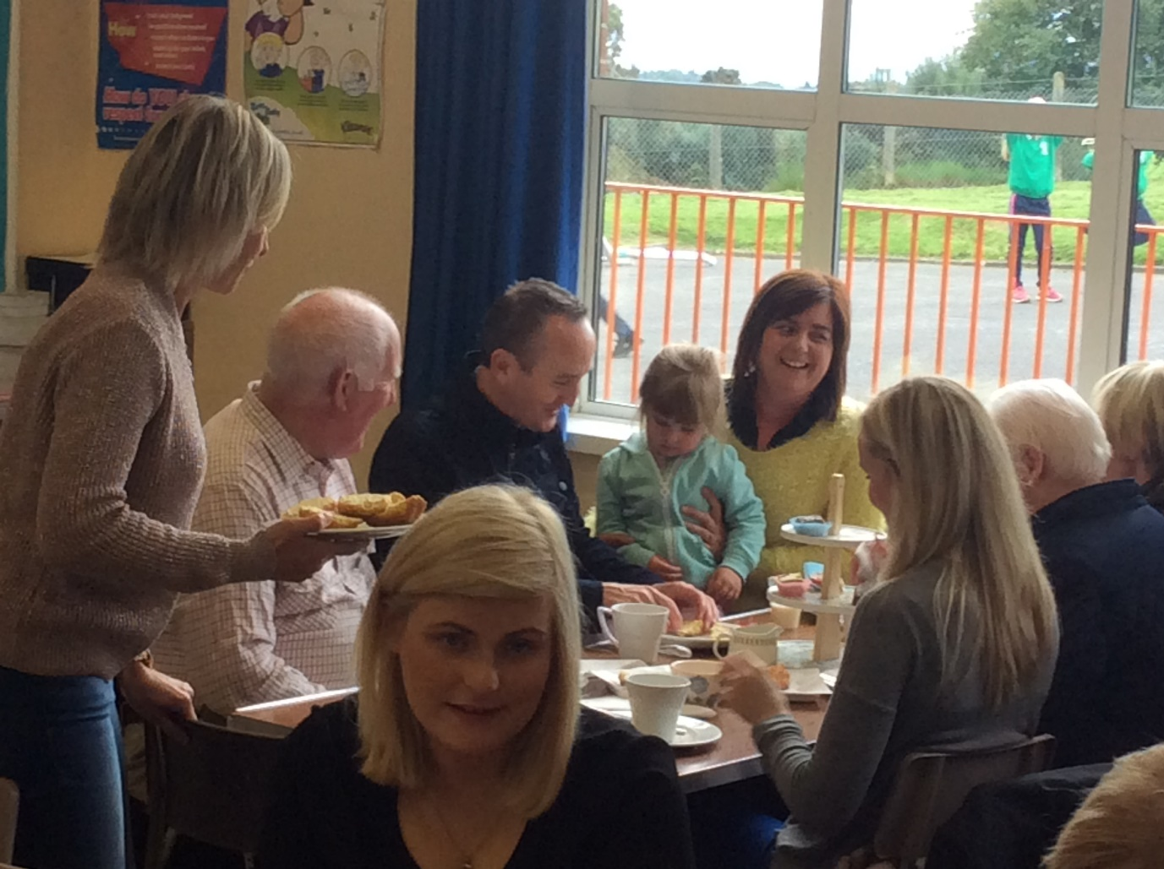

Grandparents Day

